Abstract template for the “Complexity in Soft and Condensed matter” special session

D Bonamy ¹, A. Prigent ²

¹Groupe fracture, DSM/DRECAM/SPCSI, CEA Saclay, 91 191 Gif sur Yvette, France,
² LOMC, FRE 3102 CNRS, University of Le Havre, 53 rue de Prony, 76058 Le Havre, France

A one-page abstract should be prepared in the following format: (1) Use a sheet of A4 size paper. (2) Use 12 points Times New Roman for the main text and smaller fonts may be used for figure captions. (3) The width of each line should not exceed 17.5 cm or 7.0 inch. (4) Start the first line leaving the space of 2.5 cm or 1.0 inch on the upper side. (5) Title, author's names, and affiliations should be centered. (6) Insert one blank line between the affiliations and the main text. (7) Main text should be fully justified with a single spacing. (8) Use bold face with bigger fonts for title but not for authors, affiliations, and the main text. (9) Please underline the presenting author. (10) Leave the space of 2.5 cm or 1.0 inch at lease on the bottom of the text. Page number will be printed there. (11) Deadline is 10 May 2009.

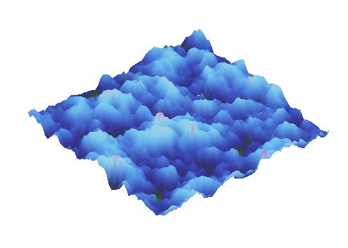
Fig.1 – Fracture surface observed through SEM
Fig.2 – Time averaged field of temperature measured within a numerical drum.

References
[1] C.R. Clemmer, T.P. Beebe Jr., Science 251 (1991) 640
[2] J. Xhie, K. Sattler, M. Ge, N. Venkateswaran, Phys. Rev. B 47 (1993) 15835
[3] R. Hentschke, B. Schurmann, J. Rabe, J. Chem. Phys. 96 (1992) 6213
[4] W.T. Pong, C. Durkan, J. Bendall, “Observation of Large-Scale Features on Graphite under Scanning Tunnelling Microscope” 12th International Colloquium on Scanning Probe Microscopy in Shizuoka, Japan 2004.
[5] J. Osing, I.V.Shvets, Surf. Sci. 417 (1998) 145
[6] V. J. Cee, D. L. Patrick, T. P. Beebe Jr., Surf. Sci. 329 (1995) 141

